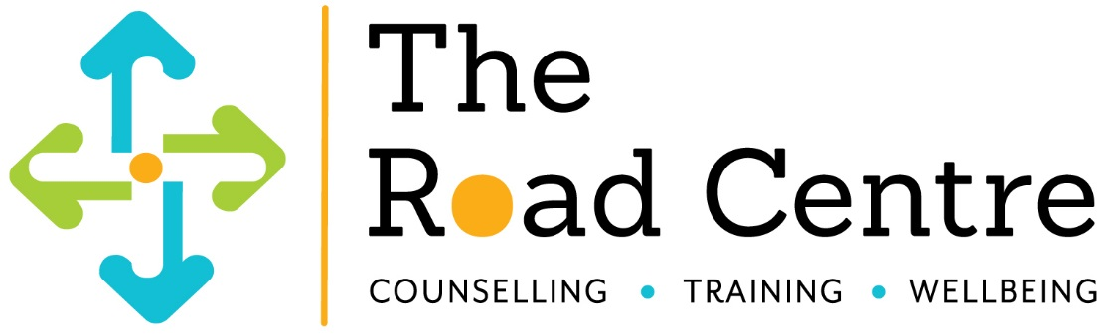

Guided Imagery – Creative Everyday Counselling
Saturday 11 November 2017
9:30am – 4.00pm
Name:

Profession:

Address:

Email address:

Contact number:

Cancellations
Cancellations with less than 1 week’s notice will be subject to 50% charge, less than 48 hours, full fee payable.

Indemnity
This booking constitutes a legally binding contract. It may be neccesary for reasons beyond the control of The Road Centre Ltd to change the programme, speaker, date or venue. In the unlikely event of a programme being cancelled, a full refund will be made.

I have read and accept the terms and conditions outlined above.

Signature

Payment methods (£60.00)
To pay via cheque, please enclose with the booking form and make the cheque payable to The Road Centre Ltd and return to the address below.

To pay via bank transfer please include your initial and surname with our reference GI17 (for example J Watson GI17) and return booking form via email or post.
Bank details: The co-operative bank sort code: 08-92-99 Account number: 69271540

The Road Centre Ltd 21a North Burns Chester le Street County Durham DH3 3TF Telephone: 0191 3891188

Website: www.theroadcentre.com E-mail: info@theroadcentre.com

